**Design doc for Access Project**

**Introduction**

***Scope***

Workers are more affected by occupational diseases than by accidents, but while in accidents the connection between the cause and the result is clear, in occupational diseases it is not simple. That is why it is important to diagnose occupational diseases, locate employees for whom there is an indication of the onset of damage as a result of their work, and suggest ways to prevent the development of disease. In some cases, it is necessary to remove an employee from work in order to maintain his health.

The project will operate with occupational health database. This database contains data from visits in different industry plants in Israel. Each visit contains name, date and specific parameters about workplaces. The data format is Access database.

The project consists of two parts. First part allows to find any specific parameter in Access database. A user enter text parameter in GUI text field and the program defines which file, table name, column name and row number contain this parameter. The output of this search will be presented in Excel table.

The second part with present visit data on the plant. The program will present list of plants in the database. The user will choose plant name and visit date. The program will find all visit details in Access database and present them in Excel table.

***Overview***

The document is design document for Access DB project of occupational health database. It includes the following parts:

1. Introduction
2. Software design description
3. Tests and monitor

***Terminology***

1. Occupational health is the field of medicine related to exposure to various chemical, physical, biological and ergonomic factors in the work setting.
2. Gothen is a person who specializes in identifying, measuring and monitoring employee exposures to physical, chemical, biological and ergonomic risk factors in the workplace, and provides solutions to reduce exposure or damage.
3. Air quality test measure the pollutants carried in the air in the form of sprays, smoke and organic vapors can harm your health.
4. Workplace noise tests measure noise volume in the plant.
5. Occupational health database of Ministry of Labor - contains data from visits in different industry plants in Israel with air quality test and noise tests measures.
6. Industry plant - contains name. id, and specific parameters
7. Plant visit - contains plant name, date, visitor name, executed tests and test results.

**Software design description**

***General flow***

1. The user will connect to the graphical interface, identify itself with user and password.
2. The user enter parameter that he wants to find in Access database. After validation that parameter is not empty and valid, the program will search the DB and return in which file, table name, column name and row number contain this parameter. Also, the Excel file will be created that include this data.
3. The user has in the GUI also list of plants in the database and can select plant name and visit date. The program will find all visit details in Access database and present them in Excel table.

All work with the GUI will be logged in the log file.

***Software architecture***

The project written in python and use the following packages:

1. Pyodbc
2. mdbtools
3. time
4. datetime
5. os.path
6. logging
7. xlwt
8. tabulate
9. Tkinter

Tools and methods that I need to lean for the project:

1. Logging – create the log file
2. Work with Access database - adding data source, connection to DB, reading and processing the data
3. Create GUI – create the GUI
4. Create table – create the table
5. Work with Excel – create excel files

The project includes the following parts: graphical interface that connect to Access DB and get all plant details, save the output work in Excel, create and update log.

***User interface***

The project will include graphical interface.

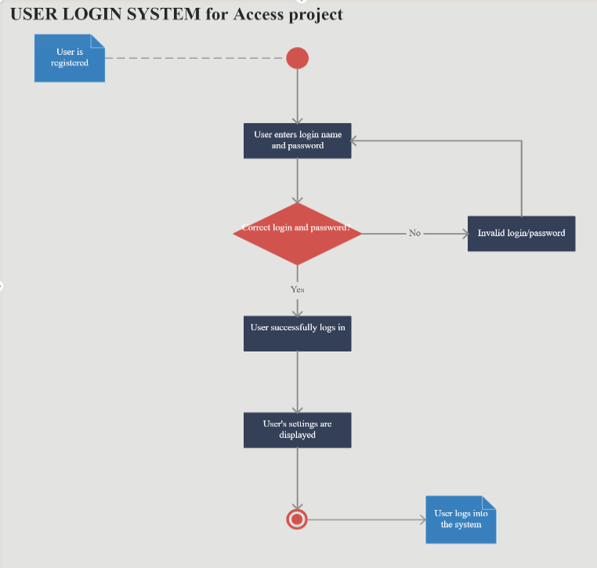

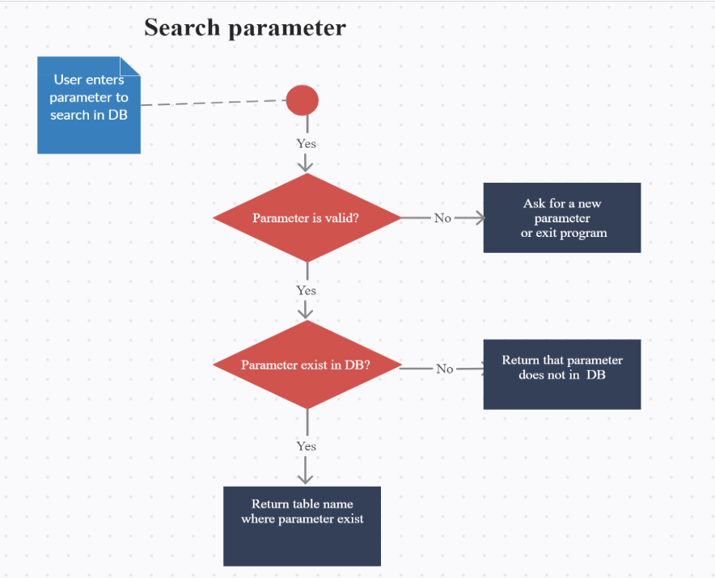

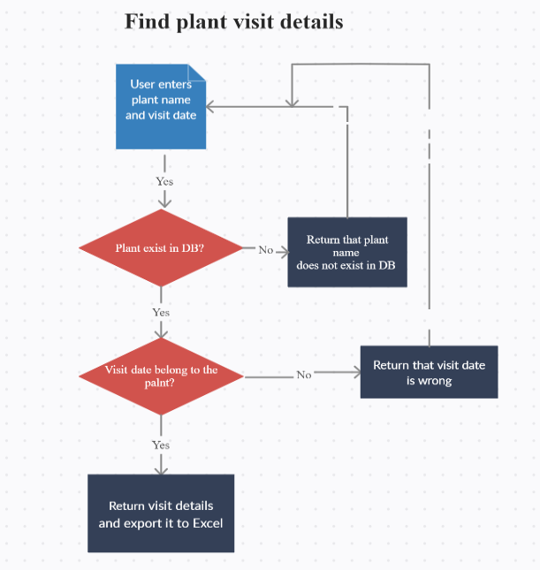

***Data handling***

The project includes working with an Access database, searching for data, working with data, and displaying it in an Excel file.

***Integration with other systems***

The project includes work with Access DB files.

**Tests and monitor**

***Tests***

The project will be tested manually.

***Logs***

The project log includes the following information:

1. Date and time
2. Log severity
3. Function that is used
4. Wrong input

***Alerts***

The project includes the following alerts:

1. Wrong user identification and authorization
2. Not able to connect to Access DB
3. Not able to connect to Excel DB
4. Not able to create log file
5. Not able to create excel file
6. Wrong input

***A/B Testing***

Not include in the project